**Student Name:**

**CMSC 311 Computer Organization**

**LAB 6: Assembly Language programming Using LC-3 Simulator**

**Instructor:** Dr. Cang Ye **Email:** [cye@vcu.edu](mailto:cye@vcu.edu) Office & Hours: E2240, TR 12-1 PM

**TA:** Lingqiu Jin **Email:** [jinl@mymail.vcu.edu](mailto:jinl@mymail.vcu.edu) Office & Hours: E2264, MW 2-3 PM

**Assignment**:

1. Write an LC-3 assembly language program that divides a positive number X by another positive number Y and stores the integer part of the result in R3, i.e., R3 = int (X/Y). Your code should use an iterative construct.
2. Write an assembly program that produce the modulo of 2 positive numbers (i.e., the remainder of the division) and store the result in R4, i.e., R4 = X % Y.

The value of X should be stored in 0x3100 and the value of Y should be stored in 0x3101. Also, let X = 0x005A and Y = 0x0007. Your program should start at 0x3000.

**Instructions:**

1. Your lab report is due no later than the date of the next class. Your lab report (in pdf format) should include your assembly code and screenshot(s). Submit both your lab report and source codes in separate files via blackboard. Please comment your code to make it easy to understand.

2. The screenshot(s) should show both your assembly code and simulation result. The code should start at address x3000. All register information, the assembly code, and the input data should be visible on the screenshot(s).

3. Grading policy: lab report 20%, source code 80%.

1. Write an LC-3 assembly language program that divides a positive number X by another positive number Y and stores the integer part of the result in R3, i.e., R3 = int (X/Y). Your code should use an iterative construct.
   1. In this program I used the subtraction method to find the division result of X and Y. First the program check if the bottom number is zero. Conditions are set to have no negative number as input in this program. The result will be stored in R3. We should see the top number and bottom number at R0 and R1 respectively at the end of each run also. Before running, we have to input the top and. Due to the available space of the screen! The first ADD instruction isn’t shown.

NOTE: THE .ASM FILES FOR BOTH 1 AND 2 WERE COMPILED FROM WEBSITE <http://spacetech.github.io/LC3Simulator/>

CODE:

.ORIG x3000

AND R0,R0, #0 ;; R0, WILL HOLD THE FIRST NUMBER

BRn #14 ;; NO NEGATIVE INTEGER IN THIS PROGRAM

AND R1,R1, #0 ;; R1, WILL HOLD THE SECOND NUMBER

LDI R0, FIRST

LDI R1, SECOND

BRnz #10 ;; CAN'T DIVISE BY ZERO AND ALSO NO NEGATIVE INTEGER IN THIS PROGRAM

AND R3,R3, #0 ;; R3 WILL HOLD THE RESULT

AND R4,R4, #0 ;; R4, WILL HOLD THE REMAINING

AND R5, R5, #0 ;; HOLD THE TEMP RESULT

NOT R2, R1 ;; CHANGE SIGN OF THE SECOND NUMBER

ADD R2, R2, #1 ;;

ADD R5, R0, R2 ;; FIRST NUMBER - SECOND NUMBER

BRn #3 ;;IF THE RESULT IS NEGATIVE--> HALT

;;ADD R0,R5,#0 ;; ELSE PUT THE RESULT OF R3 BACK INTO R0

ADD R3, R3, #1 ;; INCREASE THE COUNTER

ADD R5, R5,R2 ;; FIRST - SECOND AGAIN

BRnzp #-4 ;; UNCONDITIONAL BRANCH

HALT

FIRST .FILL x3100

SECOND .FILL x3101

.END

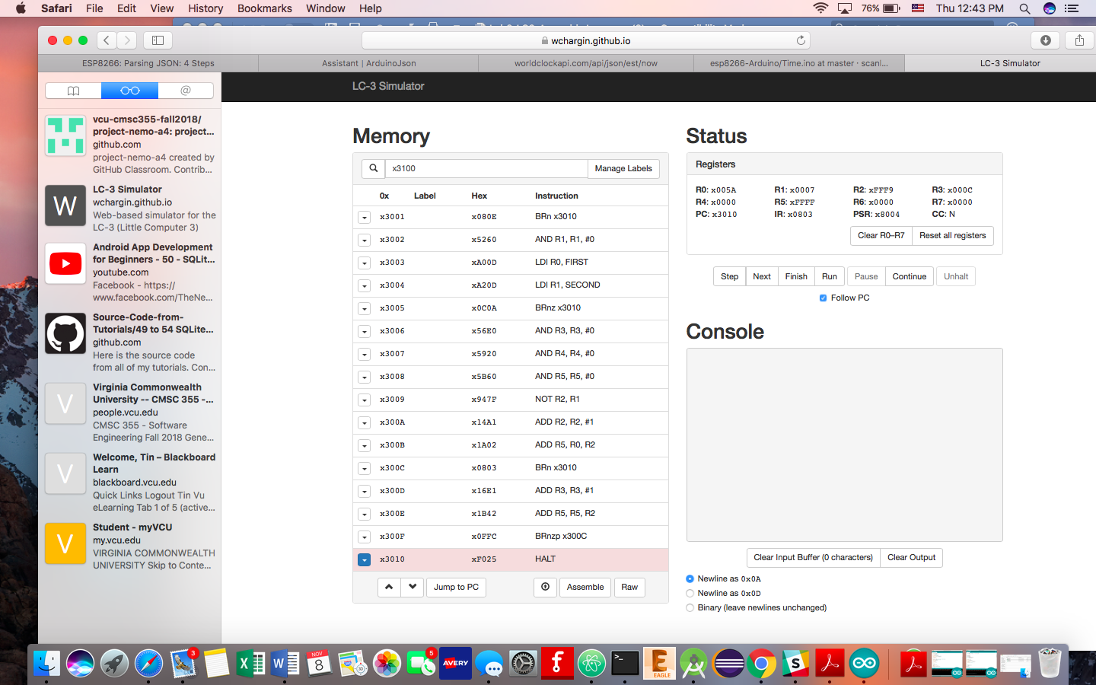

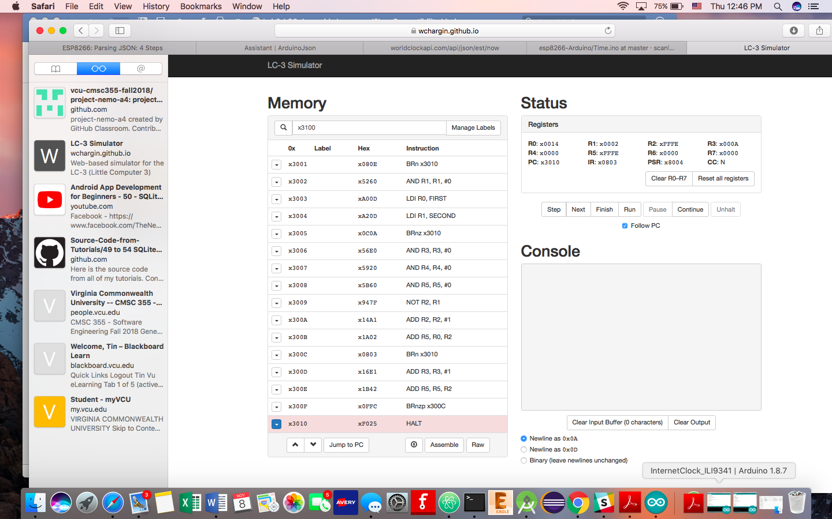

1. Write an assembly program that produce the modulo of 2 positive numbers (i.e., the remainder of the division) and store the result in R4, i.e., R4 = X % Y.
   1. This program is just a modified version of the first program in this lab. I added 2 lines after the loop to calculate the remainder of X and Y. all the preconditions and postconditions stay the same. Input at the same addresses. The remainder is stored at register R4.

CODE:

.ORIG x3000

AND R0,R0, #0 ;; R0, WILL HOLD THE FIRST NUMBER

BRn #14 ;; NO NEGATIVE INTEGER IN THIS PROGRAM

AND R1,R1, #0 ;; R1, WILL HOLD THE SECOND NUMBER

LDI R0, FIRST

LDI R1, SECOND

BRnz #10 ;; CAN'T DIVISE BY ZERO AND ALSO NO NEGATIVE INTEGER IN THIS PROGRAM

AND R3,R3, #0 ;; R3 WILL HOLD THE RESULT

AND R4,R4, #0 ;; R4, WILL HOLD THE REMAINING

AND R5, R5, #0 ;; HOLD THE TEMP RESULT

NOT R2, R1 ;; CHANGE SIGN OF THE SECOND NUMBER

ADD R2, R2, #1 ;;

ADD R5, R0, R2 ;; FIRST NUMBER - SECOND NUMBER

BRn #3 ;;IF THE RESULT IS NEGATIVE--> HALT

;;ADD R0,R5,#0 ;; ELSE PUT THE RESULT OF R3 BACK INTO R0

ADD R3, R3, #1 ;; INCREASE THE COUNTER

ADD R5, R5,R2 ;; FIRST - SECOND AGAIN

BRnzp #-4 ;; UNCONDITIONAL BRANCH

ADD R4, R5, R1 ;; STORE THE REMAINDER

HALT

FIRST .FILL x3100

SECOND .FILL x3101

.END

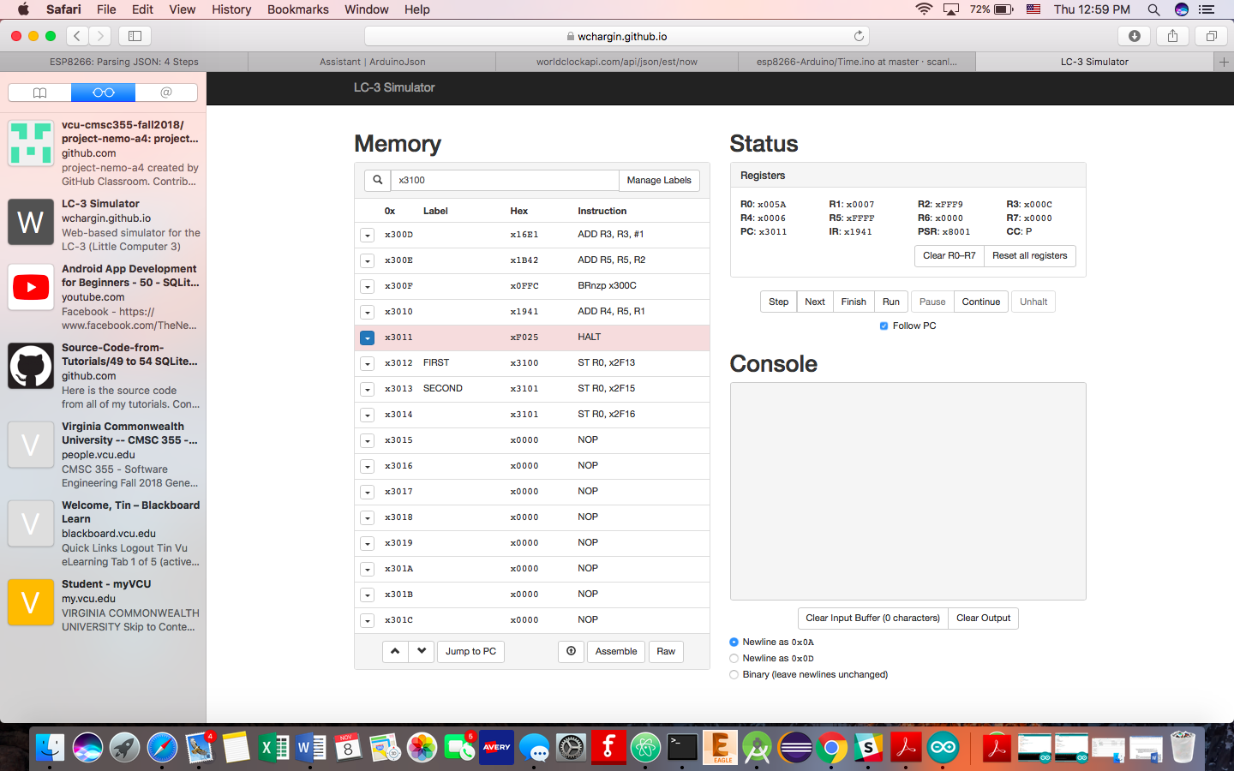

SAMPLE RUN WITH X = 90 AND Y = 7

RESULT IS IN R3: 12 (x00C)

REMAINDER IS IN R4: 6 (x006)